Bagging Ensemble Classification Results
Generated: 2026-05-29 10:27:51

Summary
Index | Metric | Value
0 | Accuracy | 0.9000
1 | N Estimators | 100
2 | Max Samples (%) | 100
3 | Max Features (%) | 100
4 | N Classes | 2
5 | Train Samples | 80
6 | Test Samples | 20
7 | N Features | 13
8 | Base Estimator | Decision Tree

Classification Report
Index | precision | recall | f1-score | support
0 | 0.8333333333333334 | 1.0 | 0.9090909090909091 | 10.0
1 | 1.0 | 0.8 | 0.8888888888888888 | 10.0
accuracy | 0.9 | 0.9 | 0.9 | 0.9
macro avg | 0.9166666666666667 | 0.9 | 0.898989898989899 | 20.0
weighted avg | 0.9166666666666667 | 0.9 | 0.898989898989899 | 20.0

Confusion Matrix
Index | Pred_0 | Pred_1
Actual_0 | 10 | 0
Actual_1 | 2 | 8

Visualizations
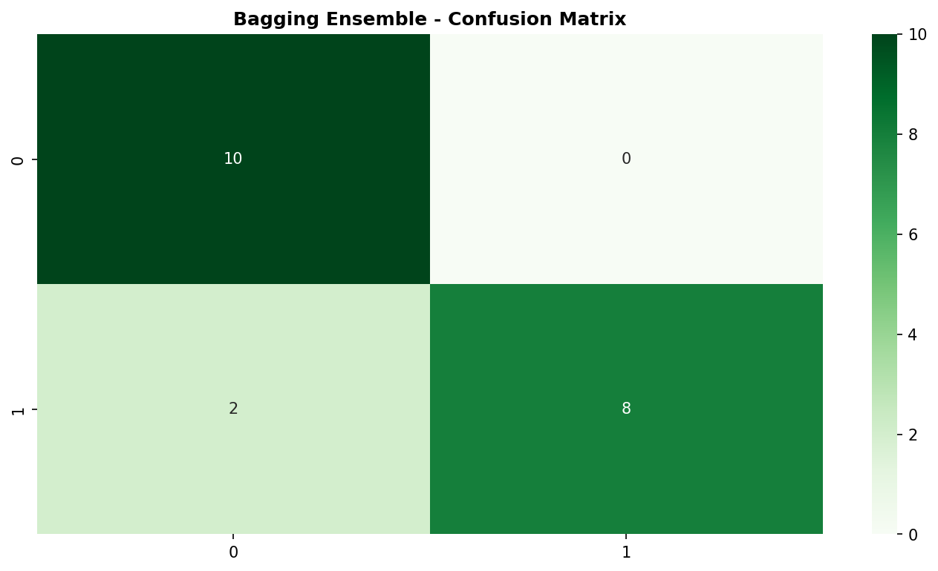
Figure 1

